Information Retrieval — Unit 3 Exam Answers
Exam Unit 3 (Q5/Q6) = Syllabus Unit V: Web Retrieval and Web Crawling

Unit Snapshot
No. | Question | Max Marks | Years Asked | Importance
3.1 | Factors influencing PageRank score; challenges in web search engines | 8 | N23, M24, N24 (×2), N25 | ★★★
3.2 | Python libraries used for web crawling | 6 | N23, M24, N24 (×2), N25 | ★★★
3.3 | Main challenges posed by the Web | 6 | N23, M24, N24, N25 | ★★★
3.4 | Components of focused web crawlers | 6 | N23, M24, N24, N25 | ★★★
3.5 | Search engine ranking function / simple ranking functions | 6 | N23, N25 | ★★
3.6 | What is page ranking? PageRank numerical (d = 0.7) | 10 | M24 | ★ (high marks)
3.7 | Parallelism in query processing | 6 | N23 | ★
3.8 | MapReduce with example | 6 | N25 | ★
N23 = Nov–Dec 2023, M24 = May–Jun 2024, N24 = Nov–Dec 2024, N25 = Nov–Dec 2025. Source file for all citations: Textbooks/IR Sem7.pdf (“PDF p.” = page of the PDF, “§” = section number in the notes).

Must-Do First (★★★)
- 3.1 PageRank factors + search-engine challenges
- 3.2 Python crawling libraries (Scrapy, BeautifulSoup)
- 3.3 Challenges posed by the Web
- 3.4 Focused crawler components
Exam strategy: Q6 (3.3 + 3.4 + “Python library”) has been asked in all four papers — the safest choice. Also practise the PageRank numerical (3.6): it carries 10 marks and the same formula answers 3.1.

Full Answers

3.1 Discuss the factors that influence a webpage’s PageRank score. Discuss the challenges involved in web search engines. ★★★
Write for: 10 marks (asked max 8) · Asked in: N23 Q5a [6], M24 Q5a [8], N24 Q5a [6] and Q5b [5], N25 Q5b [5] · Source: IR Sem7.pdf, PDF p.40–42 (§5.2.5 Link Based Ranking, §5.3 Page Ranking Algorithm — key steps, damping factor, convergence); challenges: PDF p.32 & p.35 (coverage & freshness; index size problem, §5.2). Full challenge list partly standard textbook.

Definition
PageRank (Larry Page & Sergey Brin, Stanford, used by Google) is a link-analysis algorithm that measures the importance of a web page from the number and quality of links pointing to it. A link from page T to page A is treated as a “vote” for A.

PageRank formula
$$PR\left(A\right)=\left(1−d\right)+d\left(\frac{PR\left(T_{1}\right)}{C\left(T_{1}\right)}+⋯+\frac{PR\left(T_{n}\right)}{C\left(T_{n}\right)}\right)$$
- $T_{1}…T_{n}$ = pages linking to A; $C\left(T_{i}\right)$ = number of outgoing links of $T_{i}$; $d$ = damping factor (≈ 0.85).

Part A: Factors that influence PageRank
- Number of inbound links (backlinks): more pages linking to A → higher PR.
- Quality (PageRank) of linking pages: a link from a high-PR page (e.g. a news site) is worth more than many links from unknown pages.
- Number of outbound links on the linking page: a page’s PR is divided equally among its out-links → a link from a page with few out-links passes more PR.
- Damping factor (d): probability the random surfer follows a link (1 − d = jumps to a random page); controls convergence and distribution.
- Link structure / internal linking: good internal links spread PR inside a site; dangling pages (no out-links) and rank sinks/loops affect scores.
- Relevance & authority of the linking site: topically related, trusted sites (HITS: hubs & authorities) give stronger votes.
- Link spam & manipulation: link farms, paid links are detected and penalised; nofollow links pass no PR.
- Age and stability of links / freshness of the page.
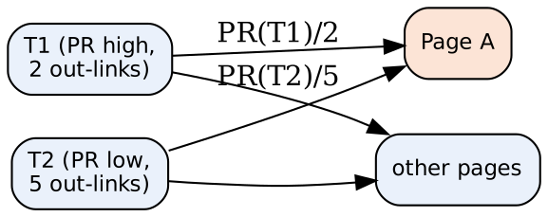
- T1, T2: pages linking to A (in-links).
- Edge labels: the share of PR each page passes = its PR ÷ its out-links.
- Page A: its PR = (1 − d) + d × sum of received shares.

Part B: Challenges in web search engines
- Scale: billions of pages, huge index; needs distributed/parallel architectures (notes: “how Google can search 30 trillion pages”).
- Coverage & freshness: crawling enough pages and keeping the index up to date (notes p.32).
- Dynamic / hidden (deep) web content: JavaScript pages, forms, databases are hard to crawl.
- Spam & manipulation: keyword stuffing, link farms, cloaking.
- Duplicate & near-duplicate pages: mirrors, copied content waste resources.
- Query ambiguity & short queries: “jaguar” (car/animal); understanding user intent.
- Ranking quality & relevance for diverse users; personalisation vs privacy.
- Multilingual & multimedia content, heterogeneous formats (HTML, PDF, images).
- Fast response (latency) and high throughput under heavy query load; fault tolerance.

Conclusion
PageRank depends mainly on the quantity and quality of in-links, out-link count of linking pages and the damping factor; search engines must also fight scale, freshness, spam, duplicates and ambiguity.
Memory trick: PageRank factors = “IQ-ODS” → Inbound links, Quality of linkers, Outbound count, Damping factor, Spam/structure. Challenges = “SCALE-D”: Size, Coverage/freshness, Ambiguity, Link spam, Efficiency (latency), Duplicates.

3.2 Define Python library used for web crawling. ★★★
Write for: 8 marks (asked max 6) · Asked in: N23 Q6a, M24 Q6a, N24 Q5c and Q6a, N25 Q5c (all 6 marks) · Source: IR Sem7.pdf, PDF p.43–46 (§5.4.2 Web Crawler Libraries, Python Scrapy — why use, features, advantages; §5.4.3 Beautiful Soup)

Definition
A web crawler (spider/bot) is a program that automatically browses the web, downloads pages and extracts data/links. Python libraries for crawling provide ready-made tools for sending HTTP requests, parsing HTML, following links and storing data. The main ones (notes): Scrapy and BeautifulSoup; others: Requests, Selenium, lxml, Puppeteer (Pyppeteer).

1. Scrapy (crawling framework)
- Fast, open-source web crawling framework in Python (first released 2008, BSD licence, v1.0 in 2015).
- Extracts data using selectors (XPath / CSS).
- Handles requests asynchronously (Twisted) → very fast; auto-throttling adjusts crawl speed.
- Feed exports in JSON, CSV, XML; built-in support for pipelines, middleware, robots.txt.
- Best for large, scalable crawling projects.

2. BeautifulSoup (HTML/XML parser)
- Library to parse HTML/XML and navigate the parse tree (find tags, attributes, text).
- Usually used with Requests (to download pages).
- Very easy for small scraping tasks; handles broken HTML; not a full crawler (no scheduling/async).

3. Other libraries
- Requests: simple HTTP GET/POST to fetch pages.
- Selenium / Puppeteer: control a real browser → crawl JavaScript-rendered (dynamic) pages.
- lxml: very fast XML/HTML parsing with XPath.

Crawling workflow with Python
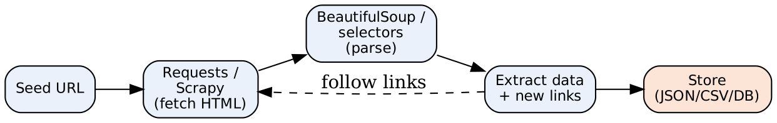
- Seed URL: starting page. Fetch: HTTP request returns HTML. Parse: build tree and select elements. Extract: required data and new links (loop back). Store: export results.

Example (BeautifulSoup)
import requests
from bs4 import BeautifulSoup
html = requests.get("https://example.com").text
soup = BeautifulSoup(html, "html.parser")
for a in soup.find_all("a"):
print(a.get("href")) # all links on the page
Scrapy spider (outline): class QuoteSpider(scrapy.Spider): name="quotes"; start_urls=[...]; def parse(self, response): yield {"text": response.css("span.text::text").get()} → run scrapy crawl quotes -o out.json.

Scrapy vs BeautifulSoup
Scrapy | BeautifulSoup
Complete crawling framework | Only a parser library
Asynchronous, very fast | Synchronous, slower
Built-in link following, pipelines, export | Needs Requests + own code
Best for large projects | Best for small/one-page tasks

Conclusion
Scrapy (framework) and BeautifulSoup (parser), with Requests/Selenium, are the main Python tools for building web crawlers and scrapers.
Memory trick: “Scrapy Scales, Soup Simplifies, Selenium Sees JavaScript”.

3.3 What are the main challenges posed by the Web? ★★★
Write for: 8 marks (asked max 6) · Asked in: N23 Q6b [5], M24 Q6b [6], N24 Q6b [5], N25 Q6b [5] · Source: Partly in IR Sem7.pdf, PDF p.32 (coverage & freshness challenge for crawlers) and PDF p.35 (index size problem for the whole Web). Structured classification: ⚠ Not found in your materials — standard textbook answer (Baeza-Yates & Ribeiro-Neto, Modern IR, Ch. 11).

Definition
The Web is a huge, distributed, dynamic and heterogeneous collection of documents. It poses challenges for IR that do not exist in a small, controlled document collection. They are grouped into data-centric and user-centric challenges.
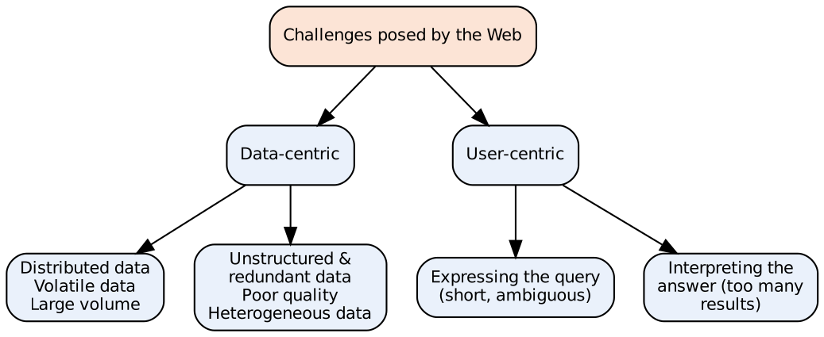

A. Data-centric challenges
- Distributed data: pages spread over millions of servers with no central control or common structure.
- Volatile (dynamic) data: pages are added, changed and deleted constantly; broken links (404) — keeping the index fresh is hard.
- Large volume: billions of pages → huge storage, crawling and indexing cost (notes: index size problem).
- Unstructured and redundant data: mostly free text/HTML; around 30% pages are duplicates/near-duplicates (mirrors).
- Quality of data: no editorial control → false, outdated, poorly written content; spam.
- Heterogeneous data: many formats (HTML, PDF, images, video), languages and character sets.
- Hidden / deep web: content behind forms, logins and JavaScript cannot be crawled easily.

B. User-centric (interaction) challenges
- How to specify a query: users type short (2–3 word), ambiguous queries and don’t know the vocabulary.
- How to interpret the answer: millions of results; users look only at the top 10 → ranking must be excellent.
- Diverse users and intents: informational, navigational, transactional queries; personalisation vs privacy.

Additional system challenges
- Adversarial IR: SEO spam, link farms, cloaking.
- Scalability & latency: answering thousands of queries per second in milliseconds.
- Politeness & legal issues while crawling (robots.txt, copyright).

Example
A query “apple” must handle fruit vs company (ambiguity), 100+ million matching pages (volume), pages updated every minute (volatility) and spam pages using “apple” keywords (quality).

Conclusion
The Web is big, dynamic, distributed, heterogeneous, low-quality in parts and used by non-expert users — search engines handle these with distributed crawling/indexing, link analysis and good ranking.
Memory trick: “DVLUQH + QI” → Distributed, Volatile, Large, Unstructured/redundant, Quality, Heterogeneous + Query formulation, Interpretation of results.

3.4 Explain the components of focused web crawlers. ★★★
Write for: 8 marks (asked max 6) · Asked in: N23 Q6c, M24 Q6c, N24 Q6c, N25 Q6c (all 6 marks) · Source: IR Sem7.pdf, PDF p.32 (“Topical or Focused Crawlers” under crawler types) and PDF p.43 (§5.4.1 Web Crawler Structure — seed URLs, URL frontier, fetcher, URL filter, parser, URL deduplication, indexer, scheduler, politeness policy, crawl control). Classifier/distiller components: standard textbook (Chakrabarti et al.).

Definition
A focused (topical) crawler is a web crawler that downloads only pages relevant to a particular topic (e.g. “cricket” or “medical research”) instead of crawling the whole web. It predicts the relevance of a page/link before downloading it, saving bandwidth and storage.

Architecture
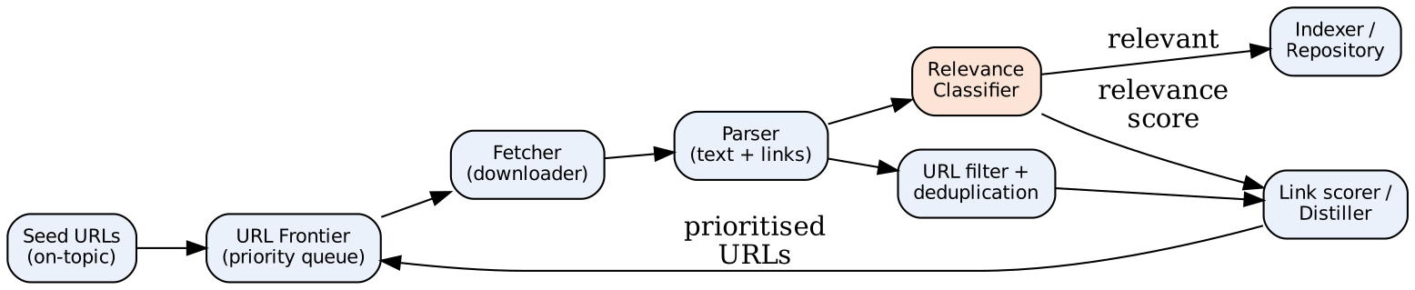

Components
- Seed URLs: starting list of highly relevant pages on the topic (from experts or a search engine).
- URL Frontier (priority queue): holds URLs to be visited; unlike a normal crawler, URLs are ordered by predicted relevance score (best-first crawling).
- Fetcher / Downloader: sends HTTP requests and downloads the HTML of the highest-priority URL; obeys robots.txt.
- Parser: extracts text, links, anchor text and metadata from the downloaded page.
- Relevance (topic) Classifier: decides how relevant the page is to the topic (e.g. Naïve Bayes, SVM, cosine similarity with a topic profile). Relevant pages are stored; irrelevant pages are discarded or given low priority.
- Link Scorer / Distiller: assigns a priority to each out-link using parent-page relevance, anchor text, URL words and hub scores (pages that link to many relevant pages).
- URL Filter & De-duplication: removes already-seen, disallowed, off-domain or duplicate URLs.
- Scheduler & Politeness policy: controls order/rate of requests so servers are not overloaded (crawl control & throttling).
- Indexer / Repository: stores relevant pages and builds the index for search.

Working (steps)
- Put seed URLs in the frontier → 2. Fetch top URL → 3. Parse → 4. Classify relevance → 5. Store if relevant → 6. Score out-links → 7. Insert into frontier by priority → repeat until budget ends.

Advantages / Applications
- Saves bandwidth, storage and time; fresher topical index.
- Used for vertical search engines (job, medical, academic search), digital libraries, competitive intelligence, news monitoring.

Conclusion
A focused crawler = normal crawler + relevance classifier + link-priority scorer, so it follows only promising links and builds a high-quality, topic-specific collection.
Memory trick: “S-F-F-P-C-L” → Seeds → Frontier → Fetcher → Parser → Classifier → Link scorer (loop). Classifier + Distiller = what makes it “focused”.

3.5 Explain search engine ranking function / simple ranking functions in detail. ★★
Write for: 8 marks (asked max 6) · Asked in: N23 Q5b “Explain search engine ranking function?” [5], N25 Q6a “Explain Simple Ranking Functions in detail” [6] · Source: IR Sem7.pdf, PDF p.31–32 (§5.2.4 Search Engine Ranking — ranking algorithms, factors), PDF p.42 (§5.3.1 Simple Ranking Functions and Evaluations — TF-IDF, BM25, evaluation: precision, recall, F1, MAP)

Definition
A ranking function is a formula that computes a relevance score for each document with respect to a query, so that results can be sorted (ranked) in decreasing order of relevance. Search engines combine content-based scores (TF-IDF, BM25) with link-based (PageRank) and user/behaviour signals.

1. Simple ranking functions
(a) Boolean / term-match count — score = number of query terms present (no weighting).
(b) TF-IDF
scoreq,d=t∈q​tft,d×logNdft
- $tf_{t,d}$ = frequency of t in d; $N$ = total docs; $df_{t}$ = docs containing t.
(c) Vector space cosine similarity
cosq,d=t​wt,q wt,dt​wt,q2t​wt,d2
(d) Okapi BM25 (probabilistic; best simple function)
BM25q,d=t∈q​logN−dft+0.5dft+0.5⋅tft,d k1+1tft,d+k11−b+b LdLavg
- $k_{1}$ (≈1.2) controls TF saturation; $b$ (≈0.75) controls length normalisation; $L_{d}$ = doc length, $L_{avg}$ = average length.
(e) Query-likelihood (language model) — score=t∈q​ptǀMd with smoothing.

2. Search engine (combined) ranking function
$$Score\left(d,q\right)=α⋅Content\left(d,q\right)+β⋅PageRank\left(d\right)+γ⋅Other\left(d\right)$$
- Content: BM25/TF-IDF, term proximity, matches in title/anchor text (fields, BM25F).
- Link-based: PageRank, HITS authority.
- Other signals: freshness, click-through rate, location, personalisation, page speed. Modern engines learn the weights with learning-to-rank.
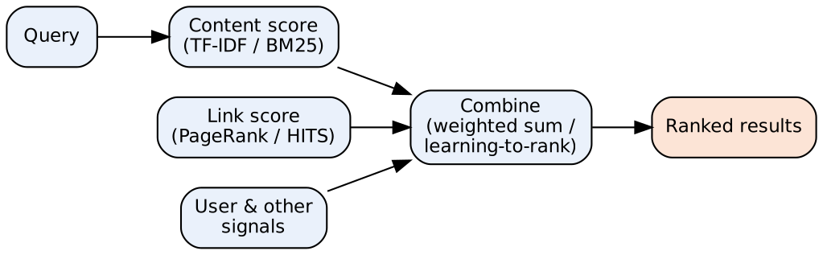
- Content score: how well text matches the query. Link score: page importance from links. User signals: clicks, freshness, location. Combine: final score used to sort results.

3. Evaluation of ranking (notes)
- Precision = relevant retrieved / retrieved; Recall = relevant retrieved / total relevant.
- F1 = $\frac{2PR}{P+R}$; MAP = mean of average precision over queries; NDCG for graded relevance; P@10.

Example
Query “solar energy”: doc1 has “solar” 3 times (df = 10) and “energy” 2 times (df = 100) in N = 1000 → TF-IDF = 3×log(100) + 2×log(10) = 3×2 + 2×1 = 8; doc2 has “energy” 5 times only → 5×1 = 5 → doc1 ranked first.

Conclusion
Simple ranking functions (TF-IDF, cosine, BM25, LM) score documents by query–content match; web search engines combine them with PageRank and user signals and evaluate them with precision, recall, MAP, NDCG.
Memory trick: “T-C-B-L” → TF-IDF, Cosine, BM25, Language model; final rank = Content + Links + Users.

3.6 What is page ranking? Calculate page rank of following web pages. Assume damping factor 0.7. ★
Write for: 12 marks (asked max 10) · Asked in: M24 Q5b [10] · Source: IR Sem7.pdf, PDF p.41–42 (§5.3 Page Ranking Algorithm — graph representation, initial scores, iterative calculation, damping factor, convergence; random-walk matrix R = βP + (1 − β)ve)

Definition
Page ranking is the process of assigning an importance score (PageRank) to every web page using the link structure of the web. A page is important if many important pages link to it. It models a random surfer who follows links with probability d and jumps to a random page with probability (1 − d).

Algorithm steps (notes)
- Graph representation: pages = nodes, hyperlinks = directed edges.
- Initial score: every page gets an equal PageRank (1, or 1/N).
- Iterative calculation: recompute each page’s PR from the PR of pages linking to it.
- Damping factor d: handles dead ends and loops; usually 0.85.
- Convergence: stop when scores change very little between iterations.
Formula: PRA=1−d+dT→A​PRTCT — $C\left(T\right)$ = number of out-links of T.

Given graph (from paper)
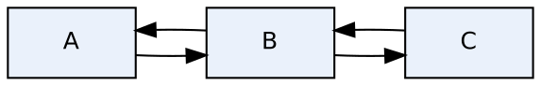
- Links: A → B, B → A, B → C, C → B. Out-degrees: C(A) = 1, C(B) = 2, C(C) = 1. d = 0.7, so (1 − d) = 0.3.

Equations
- $PR\left(A\right)=0.3+0.7×\frac{PR\left(B\right)}{2}$
- $PR\left(B\right)=0.3+0.7×\left(\frac{PR\left(A\right)}{1}+\frac{PR\left(C\right)}{1}\right)$
- $PR\left(C\right)=0.3+0.7×\frac{PR\left(B\right)}{2}$

Iterative solution (initial PR = 1 for all; latest values used immediately)
Iteration | PR(A) | PR(B) | PR(C)
0 | 1.0000 | 1.0000 | 1.0000
1 | 0.3 + 0.35(1) = 0.6500 | 0.3 + 0.7(0.65 + 1) = 1.4550 | 0.3 + 0.35(1.455) = 0.8093
2 | 0.3 + 0.35(1.455) = 0.8093 | 0.3 + 0.7(0.8093 + 0.8093) = 1.4330 | 0.8015
3 | 0.8015 | 1.4221 | 0.7978
4 | 0.7978 | 1.4169 | 0.7959
5 | 0.7959 | 1.4143 | 0.7950
… converges to | 0.7941 | 1.4118 | 0.7941

Exact (steady-state) solution
By symmetry PR(A) = PR(C) = x, PR(B) = y:
- $y=0.3+1.4x$ and $x=0.3+0.35y$
- $x=0.3+0.35\left(0.3+1.4x\right)=0.405+0.49x⇒0.51x=0.405⇒x=0.7941$
- $y=0.3+1.4\left(0.7941\right)=1.4118$

Final answer
PR(A) = 0.794, PR(B) = 1.412, PR(C) = 0.794 (sum = 3 = number of pages ✓). B has the highest PageRank because it receives links from both A and C; A and C are equal (symmetric). (Normalised form $PR=\frac{1−d}{N}+d∑…$ gives A = C = 0.265, B = 0.471, sum = 1 — same ranking.)

Conclusion
PageRank is computed iteratively until convergence; here B > A = C, showing that pages with more incoming links from other pages gain higher importance.
Exam tip: Always (1) write the formula, (2) list out-degrees, (3) write one equation per page, (4) show 2–3 iterations in a table, (5) give the converged values and check the sum = N.

3.7 What is parallelism in query processing? ★
Write for: 8 marks (asked max 6) · Asked in: N23 Q5c [6] · Source: IR Sem7.pdf, PDF p.28–30 (§5.1 Parallel Information Retrieval, §5.1.1 Parallel Query Processing — document partitioning, term partitioning, replication; Fig. 5.2 document-partitioned search engine) and PDF p.39 (Google-style cluster: load balancer, shards, result merging)

Definition
Parallel query processing uses many machines (nodes) working simultaneously to answer search queries, either to reduce response time (latency) or to increase throughput (queries per second / service rate). With n machines, a search engine can ideally reach an n-fold increase in service rate.

Two forms of parallelism
- Intra-query parallelism: one query is split and processed on many machines at once → lower response time. Achieved by index partitioning.
- Inter-query parallelism: different queries are processed on different machines at the same time → higher throughput. Achieved by replication.

1. Document partitioning
- Collection divided into n subsets (shards); each node builds a complete index for its own documents.
- A receptionist (broker) sends the query to all nodes; each returns its top-k results; receptionist merges them into the final ranking.
- Advantages: easy to build, good load balance, fault-tolerant (losing a node loses only some documents). Used by Google/most engines.
- Disadvantage: every query touches every node; global statistics (IDF) must be shared.
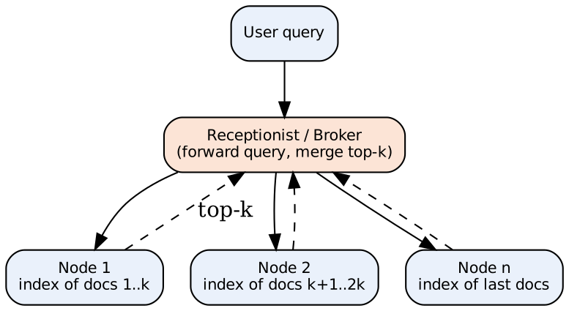
- User query enters the receptionist, which broadcasts it to all nodes.
- Each node searches only its own documents (in parallel) and returns its local top-k (dashed arrows).
- Receptionist merges the lists and returns the final top results.

2. Term partitioning
- The dictionary/postings are split by term: each node holds the complete postings lists for a subset of terms.
- A query is sent only to nodes holding its terms; postings are combined (pipelined) to compute scores.
- Advantages: fewer disk seeks, only relevant nodes busy. Disadvantages: poor load balance (popular terms overload nodes), large data transfer, hard to update → rarely used.

3. Replication (inter-query)
- Copies of the index (or of each shard) on several machines; a load balancer sends each query to a free replica → throughput ↑ and fault tolerance ↑. Popular results are cached.

Comparison
Feature | Document partitioning | Term partitioning
Split by | Documents | Terms
Nodes per query | All | Only nodes with query terms
Load balance | Good | Poor
Scalability / updates | Easy | Difficult
Used in practice | Yes (web engines) | Rarely

Conclusion
Parallelism in query processing uses partitioning (intra-query) to cut response time and replication (inter-query) to raise throughput; document partitioning + replication is the standard web-search design.
Memory trick: “Partition for Speed, Replicate for Load”; Document partitioning = Default choice.

3.8 Describe MapReduce with example. ★
Write for: 8 marks (asked max 6) · Asked in: N25 Q5a [6] · Source: IR Sem7.pdf, PDF p.30–31 (§5.1.2 MapReduce — framework for massively parallel computations, shards, map fragments, final output)

Definition
MapReduce is a programming framework (developed at Google) for massively parallel processing of very large data sets on a cluster of commodity machines. The programmer writes only two functions — Map and Reduce; the framework handles splitting, distribution, shuffling, fault tolerance and load balancing.

Phases
- Input splitting: input data divided into shards/splits (e.g. 64 MB), each assigned to a map worker.
- Map phase: map(key, value) → list of (key', value') — processes each record and emits intermediate key–value pairs.
- Shuffle & sort: intermediate pairs are grouped by key and sent to reducers (all values of one key go to the same reducer).
- Reduce phase: reduce(key', list of values) → output — aggregates the values of each key.
- Output: results written to the distributed file system (GFS/HDFS).

Example: word count
Input: Doc1 = “cat dog”, Doc2 = “dog cat dog”.
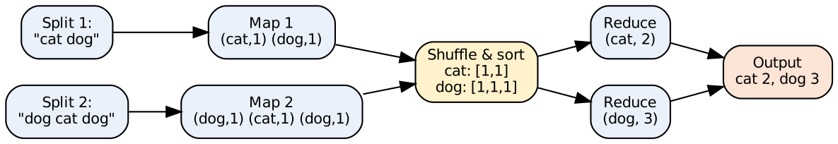
- Splits: input documents divided among map workers.
- Map: emits (word, 1) for every word.
- Shuffle & sort: groups all values of the same word together.
- Reduce: sums the list → word frequency. Output: final counts.
Pseudo-code:
map(docID, text): for each word w in text: emit(w, 1)
reduce(w, counts): emit(w, sum(counts))

MapReduce in IR
- Building an inverted index: map emits (term, docID); reduce collects the postings list for each term.
- Computing document frequencies, PageRank iterations, link graphs, duplicate detection over the whole web.

Advantages / Disadvantages
- Advantages: automatic parallelism & fault tolerance (failed tasks re-executed), scalable to thousands of machines, simple programming model, runs on cheap hardware.
- Disadvantages: high latency (batch only), not good for iterative/real-time jobs, heavy disk I/O between phases.

Conclusion
MapReduce processes huge data by Map (emit key–value pairs) → Shuffle (group by key) → Reduce (aggregate); search engines use it for index construction and web-scale analytics.
Memory trick: “Split → Map → Shuffle → Reduce → Store” = “S-M-S-R-S: Some Mangoes Should Remain Sweet”.

Last-Minute Revision Sheet — Unit 3
Topic | Key point to write
PageRank formula | $PR\left(A\right)=\left(1−d\right)+d∑PR\left(T\right)/C\left(T\right)$; d ≈ 0.85; random surfer
PageRank factors | IQ-ODS: Inbound links, Quality of linkers, Outbound count, Damping, Spam/structure
Numerical (M24) | A↔B↔C, d = 0.7 → A = C = 0.794, B = 1.412; sum = N
Search-engine challenges | SCALE-D: Size, Coverage/freshness, Ambiguity, Link spam, Efficiency, Duplicates
Web challenges | Data: distributed, volatile, large, unstructured/redundant, quality, heterogeneous; User: query, interpretation
Python libraries | Scrapy (async framework, XPath/CSS selectors, JSON/CSV export), BeautifulSoup (parser), Requests, Selenium
Focused crawler | Seeds → Frontier (priority) → Fetcher → Parser → Classifier → Link scorer/Distiller → Frontier
Crawler structure (notes) | Seed URLs, URL frontier, fetcher, URL filter, parser, dedup, indexer, scheduler, politeness
Ranking functions | TF-IDF, cosine, BM25 ($k_{1}$, b), LM; final = content + links + user signals
Evaluation | Precision, Recall, F1 = 2PR/(P+R), MAP, NDCG
Parallel query processing | Intra-query (partitioning) vs inter-query (replication); document vs term partitioning
MapReduce | Split → Map (k,v) → Shuffle/sort → Reduce → Output; word count; inverted index
HITS | Hub score (links to good authorities), Authority score (linked by good hubs)
Mnemonics: IQ-ODS · SCALE-D · “Scrapy Scales, Soup Simplifies” · DVLUQH + QI · S-F-F-P-C-L · T-C-B-L · “Partition for Speed, Replicate for Load” · S-M-S-R-S.

Assumptions & Gaps
- Unit mapping: Q5/Q6 of every paper mapped to Unit 3 = syllabus Unit V (Web Retrieval and Web Crawling).
- 3.6 graph was printed as an image in M24; read as A→B, B→A, B→C, C→B. The un-normalised formula $\left(1−d\right)+d∑$ (sum of PR = N) is used, as is common in SPPU answers; the normalised result is also given.
- ⚠ Not (fully) found in your materials: 3.3 structured data-centric/user-centric list (notes mention only coverage/freshness and index size); classifier/distiller parts of the focused crawler in 3.4; the full list of search-engine challenges in 3.1 (scale and freshness are in the notes).
- 3.2 “Define Python library is used for web crawling?” was interpreted as “Which Python libraries are used for web crawling — explain”.
- 3.5 merges “search engine ranking function” (N23) with “simple ranking functions” (N25).
- Citations give PDF page numbers of IR Sem7.pdf (two printed pages per PDF page) and section numbers printed in the notes.

